# ***Challenge Name :- Nergal's Shellgate***

**Description:** Unlock the secrets of a gu@rded file upload portal. With access granted by a secret code, only images and PDFs may pass. Embed your shell code cleverly within an upload to breach the defenses and reveal the elusive fl@g. Enter if you dare, but tread carefully—victory demands skill and stealth.

**Level:** Hard

**Solution:**

**Step-1:** You will see a file upload web application.

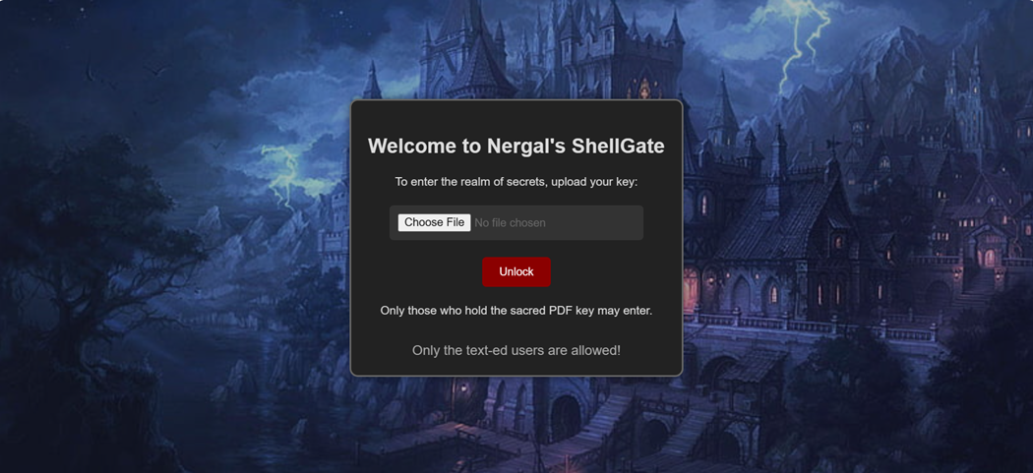

**Step-2:** You have to put HTML INPUT payload in pdf any where in heading and content and try to upload.I have implemented some restriction like php extension not allowed and some .

**Payload:** <input type=text>

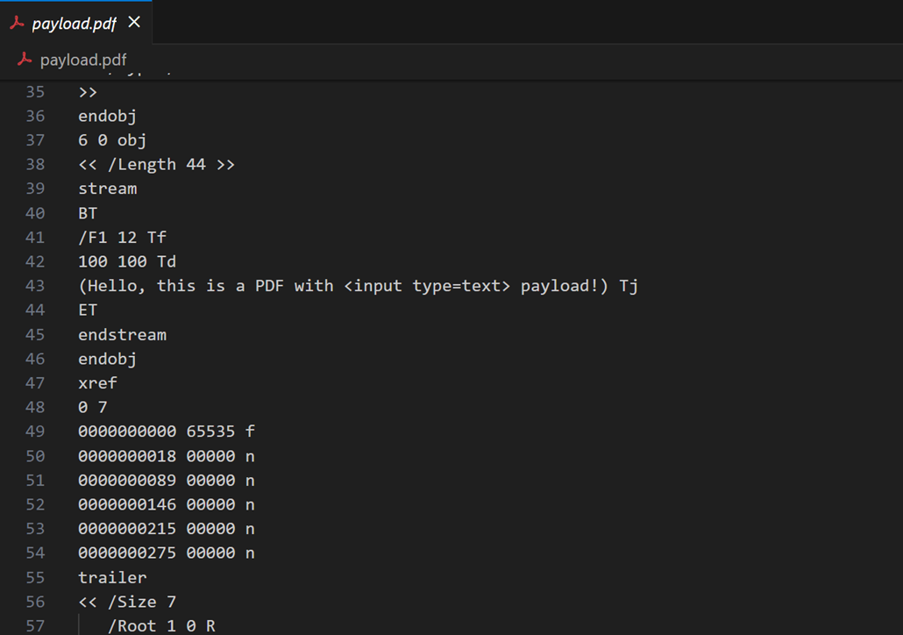

So it will open new page .

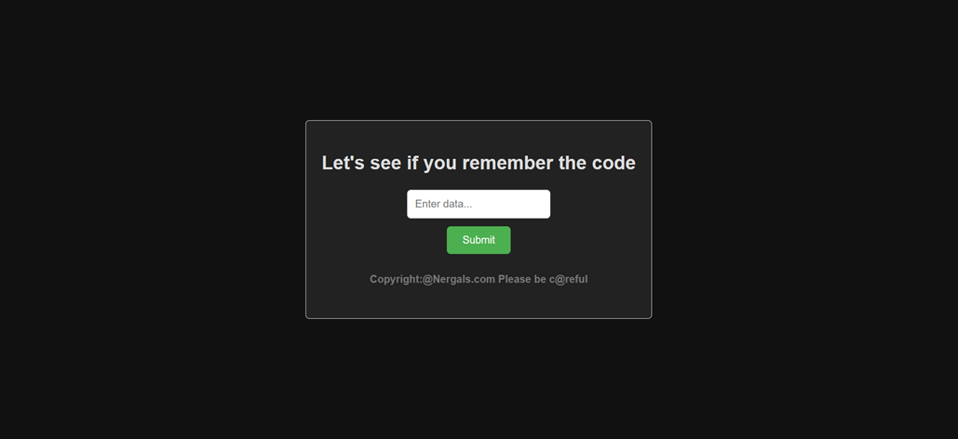

**Step-3:** You have to read the content from https://nergals.com/fl@g.txt so you can do

**file_get_contents('https://nergals.com/fl@g.txt')** Make sure here some regex implemented which detect **rce** code.

Like this.

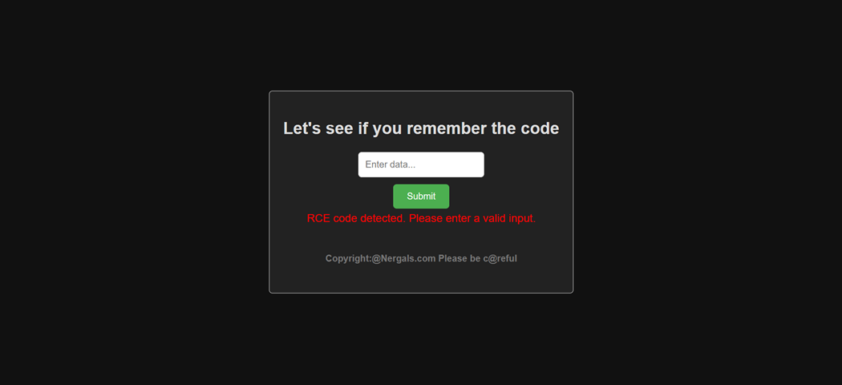

You have to put correct payload.

**Payload:****file_get_contents('https://nergals.com/fl@g.txt')**

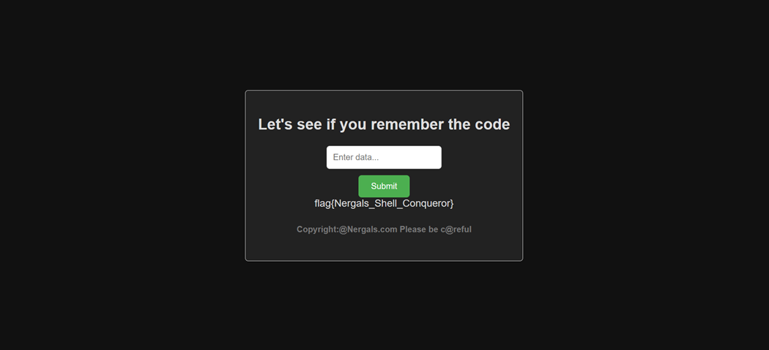

**Flag:** flag{Nergals_Shell_Conqueror}

This page is intentionally left blank